**Hayward Promise Neighborhood (HPN)** 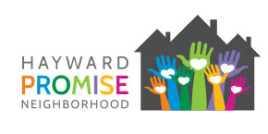

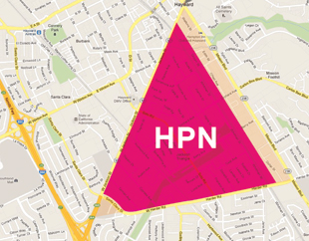

“Led by California State University, East Bay, Hayward Promise Neighborhood (HPN) is a collaborative partnership working to ensure educational success and a safe, healthy, thriving community for all living in Hayward. The partnership works to provide comprehensive, high-quality educational and social support to students that attend six schools within the Hayward Unified School District, and to ensure the long-term health, safety and economic well-being of the entire community.”

People and Place

**Location:** An area of less than 1 square mile in Hayward, CA

**People Served:** 10,662 residents; 1,674 public school children

**Community Characteristics:** 59% Hispanic, 15% Asian/Filipino, 13% African-American, and 6% White

**Poverty:** 21% of families with children live below the federal poverty line

**Access to Food and Nutrition:** Between 58% and 83% of middle to high school students receive free or reduced lunches

**College Readiness:** 40% of high school graduates have the qualifications to enter CA state universities

**Neighborhood Safety:** 30% of adults living in HPN feel that safety, violence, and crime is the number one neighborhood concern

***Source: HPN Grant Application***

Major Strategies Used

* Student Success Coaches provide case management to “at risk” students in high schools - focus on attendance and issues causing absenteeism
* Youth Enrichment Program offers online credit recovery classes during the summer to high school students
* Early Assessment Program: an assessment of “college readiness” at the end of the 11th grade – to provide support to students who wish to attend college but who are not considered ready
* Implementing Positive Behavior Interventions and Support to create a safe and supportive atmosphere
* Community oriented policing and code enforcement to foster neighborhood cohesion
* Neighborhood Partnership strategy to make Neighborhood safer and less blighted

*Sources: HPN 2016 Ad Hoc Report, HPN Grant Application*

Selected Outcomes

* Four-year adjusted cohort graduation rate: 77% in 2012 to 81% in 2016
* Percent of students who enrolled in college or university: 51% in 2013 to 67% in 2015
* Percent of students who feel safe at school and traveling to and from school: 17% in 2012 to 65% in 2016
* Percent of parents who encouraged their child to read books outside of school: 76% in 2013 to 87% in 2016

*Source: HPN 2016 Ad Hoc Report*

Long Lasting Impact on Families

*“Throughout the course of the year, it has become increasingly more evident that the collaborations formed within Hayward Promise Neighborhood are stronger than ever, and will have a long lasting impact on the families it has touched, and will continue to touch.”*

* Home Visitation Nurse, HPN

Source: HPN 2016 Ad Hoc Report